EXPERIMENT 5
NAME: Karthik V
ROLL NO: 240701234

TASK ANALYSIS AND MANAGEMENT
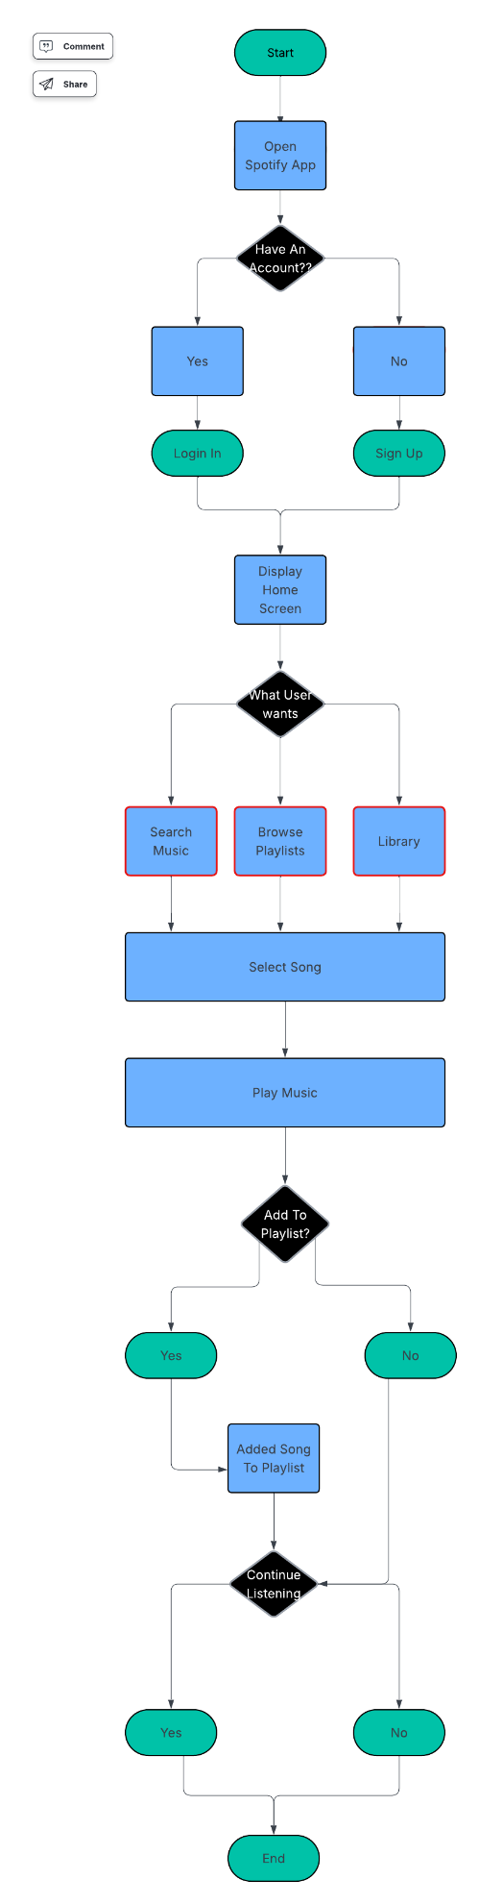
WIREFRAME
SCREEN 1


SCREEN 2


SCREEN 3


